|  |  |
| --- | --- |
| cetlogo ***CHEMICAL ENGINEERING TRANSACTIONS***  ***VOL. , 2024*** | A publication of  aidiclogo_grande |
| The Italian Association  of Chemical Engineering  Online at www.cetjournal.it |
| Guest Editors: Leonardo Tognotti, Rubens Maciel Filho, Viatcheslav Kafarov  Copyright © 2024, AIDIC Servizi S.r.l. **ISBN** 979-12-81206-09-0; **ISSN** 2283-9216 | |

Energy and Exergy Analysis for Hydrothermal Gasification Integrated with Anaerobic Digestion

Fadilla Noor Rahmaa,\*, Khanh-Quang Trana

aNorwegian University of Science and Technology, Høgskoleringen 1, Trondheim 7034, Norway

bSINTEF Energy Research, Sem Sælands vei 11, Trondheim 7034, Norway

[fadilla.n.rahma@ntnu.no](mailto:fadilla.n.rahma@ntnu.no)

Anaerobic digestion (AD) of wet and low-grade biomass materials plays an important role in the transition to sustainable energy resources. However, challenges related to digestate management and feedstock scarcity still hinder its implementation. Digestate recycling via hydrothermal gasification (HTG) can help overcoming these challenges. However, HTG process is very energy sensitive and needs a good strategy of process and heat integration. In this work, pinch analysis is carried out to identify potentials for heat integration for an integrated system of HTG with AD. The heat exchanger system is subsequently optimized to achieve the minimum energy requirement (MER) determined from the pinch analysis. Furthermore, exergy analysis is implemented to pinpoint the thermodynamic inefficiencies of the unit operations within the process. It was found that process units with biochemical and chemical reactions, i.e., AD, HTG, and combustor contribute to the largest exergy destruction. In addition, the gas turbine and steam turbine systems also have low exergetic performance.

* 1. Introduction

Biogas produced through anaerobic digestion (AD) technology plays a crucial rule in the global transition towards renewable and sustainable energy sources. The large-scale implementation of this technology is however still hindered by significant challenges related to digestate management (Nkoa, 2014) and feedstock scarcity (Divya et al., 2015). Integration of AD with hydrothermal gasification (HTG) can overcome these problems. In the integration concept, digestate from AD is further processed in HTG to generate producer gas. This integration allows AD to utilize a wider range of feedstock materials while also reducing the digestate management problems. Furthermore, the producer gas can either be recycled to enhance biogas production in the AD (Yang et al., 2020), or utilized for heat and power generation.

The HTG process is carried out at supercritical condition. A substantial amount of energy is required to reach the supercritical temperature and pressure, making HTG a very energy sensitive process. A good strategy for analysing and improving energy efficiency is therefore crucial in AD-HTG process development.

Pinch analysis is a widely implemented tool which involves a systematic method to identify the maximum heat recovery potential in a process. The method determines the minimum energy requirement (MER) of the process, which can be achieved through a detailed design of heat exchanger network (HEN) (Kemp, 2011). However, pinch analysis is only applicable for heat transfer processes, and is not suitable for other processes involving pressure and composition changes (Bandyopadhyay et al., 2019). Exergy analysis can be applied to overcome this limitation. This method provides a quantitative measure of process inefficiency by determining exergy destruction in a process, which indicates the process irreversibility (Bandyopadhyay et al., 2019).

In the present study, a conceptual process design of integrated AD-HTG with power production and producer gas recycle is proposed. Pinch analysis and exergy analysis are implemented to identify the heat integration potentials and pinpoint thermodynamic inefficiencies of the proposed process. To the best of the authors’ knowledge, studies involving energy and exergy analysis of such system have not been conducted before.

* 1. Methods
     1. System Description

The Aspen Plus model of the integrated system is presented in Figure 1. The key operating parameters used in the simulation are listed in Table 1, and the feedstock composition (*FEED*) is displayed in Table 2.

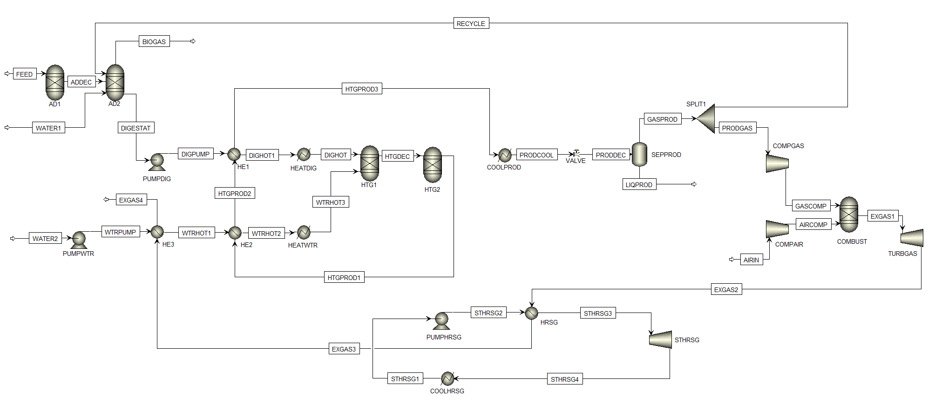

Figure 1: Process flow diagram of the integrated system in Aspen Plus

Table 1. Process parameters for Aspen Plus simulation

|  |  |  |
| --- | --- | --- |
| Process Parameters | Value | Units |
| Anaerobic Digestion |  |  |
| Feedstock mass | 10000 | kg/hr |
| Temperature | 45 | oC |
| Pressure | 1 | bar |
| Hydrothermal Gasification |  |  |
| Temperature | 600 | oC |
| Pressure | 250 | bar |
| Gas Turbine |  |  |
| Turbine inlet temperature | 1500 | oC |
| Compressor outlet pressure | 20 | bar |
| HRSG and Steam Turbine |  |  |
| HRSG outlet pressure | 200 | bar |

Table 2. Feedstock composition (Naqi et al., 2019)

|  |  |
| --- | --- |
| Component | Composition, % |
| Proximate Analysis |  |
| Fixed Carbon | 23.6 |
| Volatile Matter | 70.4 |
| Ash | 6.0 |
| Ultimate Analysis |  |
| Carbon | 47.29 |
| Hydrogen | 5.06 |
| Nitrogen | 0.8 |
| Chlorine | 0 |
| Sulfur | 0.22 |
| Oxygen | 40.63 |

*2.2.1. Anaerobic Digestion (AD)*

The AD process is modelled using Buswell equation (Symons and Buswell, 1933), which estimates AD products based on theoretical stoichiometric estimation. This approach has been adopted in earlier works (Nguyen et al., 2014, Naqi et al., 2019, Skorek-Osikowska et al., 2020) and is selected in the present study to reduce the model complexity. According to the Buswell equation, the volatile matter in the AD feedstock is converted into CH4, CO2, NH3, and H2S. The stoichiometric calculation of the conversion is represented by Equation (1).

|  |  |
| --- | --- |
| $$C_{a}H_{b}O_{c}N_{d}S_{e}+\left(a-\frac{b}{4}-\frac{c}{2}+\frac{3d}{4}+\frac{e}{2}\right)H_{2}O→\left(a+\frac{b}{8}-\frac{c}{4}-\frac{3d}{8}-\frac{e}{4}\right){CH}_{4}+\left(\frac{a}{2}-\frac{b}{8}+\frac{c}{4}+\frac{3d}{8}+\frac{e}{4}\right){CO}_{2}+d{NH}_{3}+eH_{2}S$$ | (1) |

In the Aspen Plus simulation, the AD process is theoretically represented by two RYIELD blocks (*AD1* and *AD2*). Since the AD feedstock is defined as a non-conventional component, the first RYIELD (*AD1*) is used to breakdown the feedstock volatile matter into carbon, hydrogen, oxygen, nitrogen, and sulfur. The calculation is carried out by employing a calculator block connected to the reactor. The fictitious components from *AD1* flow into the second RYIELD (*AD2*), which is connected to another calculator block based on Equation (1). The water (*WATER1*) and recycle (*SYN-REC*) streams also enter the AD system through the *AD2* block. It is assumed that the fixed carbon and ash components in the feedstock remain undigested during the AD process (Naqi et al., 2019). Two streams are produced from the AD system, i.e., *BIOGAS* and *DIGESTAT;* the latter is sent to the HTG section for further processing.

*2.2.2. Hydrothermal Gasification (HTG)*

The HTG section is modelled according to the Gibbs free energy minimization principle, which is a widely applied method in HTG modelling studies (Hantoko et al., 2018, Okolie et al., 2020). The previous studies confirmed that the modelling results were in good agreement with experimental data. Furthermore, our earlier study (Rahma et al., 2023) has also validated the HTG model against experimental data from the HTG of cornstarch. It was found that the model predicts the producer gas composition with a high accuracy.

Two streams enter the HTG reactor separately, i.e., *DIGESTAT* and additional water (*WATER2*). Both streams are pumped and preheated prior to entering the reactor. The reactor system is represented with two reactor blocks, i.e., RYIELD (*HTG1*) and RGIBBS (*HTG2*). The RYIELD (*HTG1*) block is employed to break down the non-conventional fixed carbon compound in the *DIGESTAT* stream into its elements. These elements are subsequently sent to the RGIBBS (*HTG2*) block, which performs the Gibbs free energy minimization. The reaction produces the stream *HTGPROD1,* consisting of producer gas and supercritical water. This stream is cooled and depressurized before being sent to *SEPPROD* to separate the producer gas (*GASPROD*) from the condensed water (*LIQPROD*).

*2.2.3. Combined Cycle*

The producer gas obtained from HTG is split into two streams; the first stream (*RECYCLE*) is recycled into the AD system, whereas the second stream (*PRODGAS*) is sent to a combined-cycle power generation system. Compressed producer gas (*GASCOMP*) and air (*AIRCOMP*) streams are combusted in a combustor (*COMBUST*). This process produces the stream *EXGAS1*, which is sent to turbine *TURBGAS* for power generation. The remaining energy in the turbine outlet stream (*EXGAS2*) is recovered through a heat recovery steam generator system (*HRSG*), where steam is generated and sent to a steam turbine (*STHRSG*).

* + 1. Pinch Analysis

Pinch analysis is carried out to identify the possibility of reducing the energy consumption of the system by heat integration. Initially, a preliminary process layout including the operating conditions of the process units is set up in the Aspen Plus simulation. The required thermal data is extracted from the simulation, and the available heat sinks and sources are identified according to this data. The pinch analysis follows the procedure published by Kemp (Kemp, 2011), with ΔTmin set at 10 oC. The analysis results in minimum energy requirement (MER) target which corresponds to minimum heating and cooling demand. A heat exchanger network (HEN) is subsequently developed to meet this target, resulting in an updated and optimized process layout, as presented in Figure 1.

* + 1. Exergy Analysis

Exergy is defined as the maximum work that can be extracted from a system when it is brought to equilibrium with the surroundings, i.e., the reference environment (Dincer and Rosen, 2012). The exergy of a stream is the total of its kinetic, potential, physical and chemical exergy. In the present study, it is assumed that both kinetic and potential exergy can be neglected, thus only physical and chemical exergy are considered in the analysis.

|  |  |
| --- | --- |
| $${ex}_{tot}={ex}_{ph}+{ex}_{ch}$$ | (2) |

In Equation (2), ${ex}_{tot}$, ${ex}_{ph}$, and ${ex}_{ch}$ represent the total exergy in a stream, physical exergy, and chemical exergy in kJ/kg, respectively.

The physical or thermomechanical exergy, represented by Equation (3), is the usable energy in a stream due to temperature and pressure differences with the environment (Kotas, 2012).

|  |  |
| --- | --- |
| $${ex}_{ph}=\left(h-h_{0}\right)-T_{0}\left(s-s_{0}\right)$$ | (3) |

In Equation (3), $h$, $T$, and $s$ represent enthalpy (kJ/kg), temperature (K), and entropy (kJ/kg K), respectively, while the subscript $0$ denotes the reference environment.

The chemical exergy, calculated by Equation (4), is an exergy component which exists due to differences in chemical composition between the system and the reference environment. Equation (4) consists of two terms; the first term is the sum of individual species exergy; while the second term is exergy resulting from mixing different species (Dincer and Rosen, 2012).

|  |  |
| --- | --- |
| $${\tilde{ex}}_{ch}=\sum{x_{i}}{{\tilde{ex}}^{0}}_{ch,i}+\tilde{R}T_{0}\sum{x_{i}}ln\left(γ_{i}x_{i}\right)$$ | (4) |

In Equation (4), $x_{i}$, ${{\tilde{ex}}^{0}}_{ch,i}$, and $γ_{i}$ represent the mole fraction, standard molar chemical exergy (kJ/kmol), and activity coefficient of component i; whereas $\tilde{R}$ and $T_{0}$ represent the gas constant (kJ/kmol K) and reference temperature (K), respectively. The molar chemical exergy can be converted to a mass basis, ${ex}_{ch}$ (kJ/kg) by dividing with average molecular mass of the stream.

The data required for the exergy analysis are extracted from the Aspen Plus simulation. However, for some streams containing non-conventional components with known elemental composition, the chemical exergy are calculated using Equation (5) (Song et al., 2012).

|  |  |
| --- | --- |
| $${ex}_{ch}=363.439C+1075.633H-86.308O+4.140N+190.798S-21.100A$$ | (5) |

In Equation (5), $C$, $H$, $O$, $N$, $S$, and $A$ represent the mass percentage of carbon, hydrogen, oxygen, nitrogen, sulfur, and ash in the stream, respectively.

After the total exergy for all streams are calculated, the irreversibility or exergy destruction can be calculated according to the exergy balance, as presented in Equation (6)-(8). These equations are applied to each process unit.

|  |  |
| --- | --- |
| $${ex}_{in}={ex}_{out}+{ex}_{destruction}$$ | (6) |
| $${ex}_{in}=\sum_{i}{{ex}_{tot in,i}}$$ | (7) |
| $${ex}_{out}=\sum_{i}{{ex}_{tot out,i}}+{ex}_{Q}+{ex}_{W}$$ | (8) |

In Equation (6)-(8), ${ex}_{in}$, ${ex}_{out}$, and ${ex}_{destruction}$ represent the input exergy, output exergy, and exergy destruction, respectively. Input exergy (${ex}_{in}$) is the sum of total exergy in all the streams entering a process unit (${ex}_{tot in,i}$), as shown in Equation (7). On the other hand, output exergy (${ex}_{out}$) is the sum of total exergy from the streams leaving a process unit (${ex}_{tot out,i}$), exergy associated with heat interaction (${ex}_{Q}$), and exergy associated with work (${ex}_{W}$).

The exergy efficiency of each process unit can be calculated with Equation (9).

|  |  |
| --- | --- |
|  | (9) |

* 1. Results and Discussion

The proposed process design is analyzed with the aid of pinch analysis to optimize the heat integration. The pinch analysis results in composite curves and grand composite curves as displayed in Figure 2 (a) and (b), respectively. The largest heating demand is for the heating of the digestate and water prior to entering the HTG reactor, whereas the highest cooling demand is due to reducing the HTG product’s temperature before the water separation. The pinch point is located at 267 oC. This means that no external heating is required below this temperature, and no external cooling should be provided above this temperature. According to the pinch analysis result, the minimum heating and cooling duty are 1138.5 kW and 550.9 kW, respectively. To achieve this minimum energy requirement target, HE1 and HE2 are employed to recover the heat from HTG product stream for preheating water and digestate streams prior to entering the reactor. In addition, HE3 is employed to recover the remaining heat in the exhaust gas stream and utilize it for preheating of the water stream. Additional heating and cooling from utility is however still needed, i.e., for heating of digestate and water at higher temperature (HEATDIG and HEATWTR), and for further cooling of the HTG products (COOLPROD).

Table 3 presents the exergy destruction in different process units in the simulated process, as calculated from the exergy analysis. The exergy efficiency of the process units are shown in Figure 3.

|  |  |  |  |
| --- | --- | --- | --- |
| (a) |  | (b) |  |

Figure 2: (a) Composite curves and (b) grand composite curves from pinch analysis

Table 3. Exergy destruction in process units calculated from exergy analysis

|  |  |  |  |  |  |  |
| --- | --- | --- | --- | --- | --- | --- |
| Process Unit | AD | PUMPDIG | HEATDIG1 | HEATDIG2 | HTG | |
| Exergy destruction, kJ/kg FEED | 3094.64 | 5.51 | 111.50 | 27.29 | 575.67 | |
| Process Unit | PUMPWTR | HEATWTR1 | HEATWTR2 | HEATWTR3 | COOLPROD | | |
| Exergy destruction, kJ/kg FEED | 13.54 | 16.58 | 37.42 | 157.05 | 27.55 | | |
| Process Unit | VALVE | SEPPROD | COMPGAS | COMPAIR | COMBUST | | |
| Exergy destruction, kJ/kg FEED | 270.98 | 206.65 | 5.73 | 18.95 | 887.03 | | |
| Process Unit | TURBGAS | HRSG | STHRSG | COOLHRSG | | PUMPHRSG | | |
| Exergy destruction, kJ/kg FEED | 3661.96 | 155.82 | 72.33 | 22.83 | | 7.92 | | |

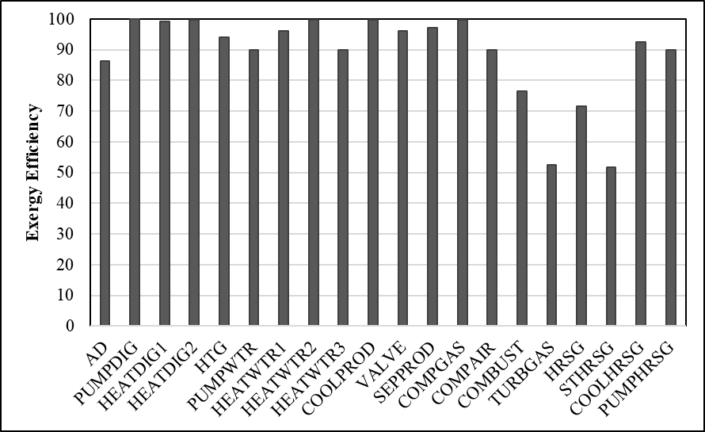

Figure 3: Exergy efficiency of process units calculated from exergy analysis

According to these results, the process units involving chemical and biochemical reactions, i.e., HTG, AD, and combustion chamber (*COMBUST*), are responsible for the highest exergy destruction and therefore relatively low exergy efficiency. This can be attributed to the chemical irreversibility in these units, in addition to heat loss for the case of high-temperature systems such as HTG and combustion chamber. Furthermore, the formation of product streams with lower standard chemical exergy such as CO2 and H2O also contributes to the large exergy destruction (Rahbari et al., 2018). Previous study concerning exergy analysis of AD-pyrolysis integrated plant also found that exergy destruction in the digester is one of the largest among the other unit operations (Ebrahimi and Houshfar, 2022).

The exergetic performance of the gas turbine unit (*TURBGAS*) is also comparatively low among the other process units, with the highest exergy destruction. The exergy efficiency of the steam turbine (*STHRSG*) is also low, although the exergy destruction is relatively small due to the smaller mass flow rate of the working fluid. A strategy that can be implemented to improve the performance of the gas turbine system is to increase the inlet temperature. In addition, the overall gas turbine system can be improved by employing a better air-fuel ratio of the combustion chamber and and modifying the turbine cycle, i.e., adding regeneration, intercooling, or reheating to the system (Ibrahim et al., 2017).

The exergy destruction in other process units such as separator, pumps, and heat exchangers are comparatively low than the process units discussed above. In the separator (*SEPPROD*), exergy destruction mainly takes place due to the unusable liquid stream (*LIQPROD*) exiting the process unit. The exergy destruction in the heat exchangers is mainly attributed to the heat transfer between the hot and cold streams. Furthermore, in the pressure changers such as pumps and valve, the exergy destruction can be associated with the pressure difference between the inlet and outlet streams (Rahbari et al., 2018).

* 1. Conclusions

A conceptual process design of integrated AD-HTG with power production and producer gas recycle is proposed in this study. The process is analysed with the aid of pinch analysis to optimize the heat integration and achieve the minimum energy requirement (MER) target. The heat exchangers arrangement is updated according to the pinch analysis result. Subsequently, exergy analysis is carried out to determine the irreversibility of the process units. The largest exergy destruction is associated with units involving chemical and biochemical reactions such as AD, HTG, and combustor, as well as gas and steam turbine systems. The analysis carried out in this study helps to pinpoint the focus of process improvement in the development of integrated AD-HTG system.

Acknowledgments

This work was supported by the BioSynGas project partly funded by the Research Council of Norway (Project Number: 319723).

References

Bandyopadhyay R., Alkilde O.F., Upadhyayula S., 2019, Applying Pinch and Exergy Analysis for Energy Efficient Design of Diesel Hydrotreating Unit, Journal of Cleaner Production, 232, 337-349.

Dincer I., Rosen M.A., 2012, Exergy: Energy, Environment and Sustainable Development, Newnes.

Divya D., Gopinath L., Christy P.M., 2015, A Review on Current Aspects and Diverse Prospects for Enhancing Biogas Production in Sustainable Means, Renewable and Sustainable Energy Reviews, 42, 690-699.

Ebrahimi A., Houshfar E., 2022, Thermodynamic Analysis and Optimization of the Integrated System of Pyrolysis and Anaerobic Digestion, Process Safety and Environmental Protection, 164, 582-594.

Hantoko D., Su H., Yan M., Kanchanatip E., Susanto H., Wang G., Zhang S., Xu Z., 2018, Thermodynamic Study on the Integrated Supercritical Water Gasification with Reforming Process for Hydrogen Production: Effects of Operating Parameters, International Journal of Hydrogen Energy, 43(37), 17620-17632.

Ibrahim T.K., Basrawi F., Awad O.I., Abdullah A.N., Najafi G., Mamat R., Hagos F., 2017, Thermal Performance of Gas Turbine Power Plant Based on Exergy Analysis, Applied Thermal Engineering, 115, 977-985.

Kemp I.C, 2011, Pinch Analysis and Process Integration: A User Guide on Process Integration for the Efficient Use of Energy, Elsevier, Oxford, UK.

Kotas T.J., 2012, The Exergy Method of Thermal Plant Analysis, Paragon Publishing, Essex, UK.

Naqi A.J., Kuhn N., Joseph B., 2019, Techno-economic Analysis of Producing Liquid Fuels from Biomass via Anaerobic Digestion and Thermochemical Conversion, Biomass and Bioenergy, 130, 105395.

Nguyen H. H., Heaven S., Banks C., 2014, Energy Potential from the Anaerobic Digestion of Food Waste in Municipal Solid Waste Stream of Urban Areas in Vietnam, International Journal of Energy and Environmental Engineering, 5. 365-374.

Nkoa R., 2014, Agricultural Benefits and Environmental Risks of Soil Fertilization with Anaerobic Digestates: A Review, Agronomy for Sustainable Development, 34, 473-492.

Okolie J.A., Nanda S., Dalai A.K., Kozinski J.A., 2020, Hydrothermal Gasification of Soybean Straw and Flax Straw for Hydrogen-rich Syngas Production: Experimental and Thermodynamic Modeling, Energy Conversion and Management, 208, 112545.

Rahbari A., Venkataraman M.B., Pye J., 2018, Energy and Exergy Analysis of Concentrated Solar Supercritical Water Gasification of Algal Biomass, Applied Energy, 228, 1669-1682.

Rahma F.N., Li T., Khalil R.A., Tran Q.K., 2023, Hydrothermal Gasification of Biogas Digestate: A Thermodynamic Study on Effects of Process Parameters Using Aspen Plus, Chemical Engineering Transactions, 105, 541-546.

Skorek-Osikowska A., Martín-Gamboa M., Iribarren D., García-Gusano D., Dufour J., 2020, Thermodynamic, Economic and Environmental Assessment of Energy Systems Including the Use of Gas from Manure Fermentation in the Context of the Spanish Potential, Energy, 200, 117452.

Song G., Xiao J., Zhao H., Shen L., 2012, A Unified Correlation for Estimating Specific Chemical Exergy of Solid and Liquid Fuels, Energy, 40(1), 164-173.

Symons G., Buswell A., 1933, The Methane Fermentation of Carbohydrates1, 2, Journal of the American Chemical Society, 55(5), 2028-2036.

Yang Z., Liu Y., Zhang J., Mao K., Kurbonova M., Liu G., Zhang R., Wang W., 2020, Improvement of Biofuel Recovery from Food Waste by Integration of Anaerobic Digestion, Digestate Pyrolysis and Syngas Biomethanation under Mesophilic and Thermophilic Conditions, Journal of Cleaner Production, 256, 120594.